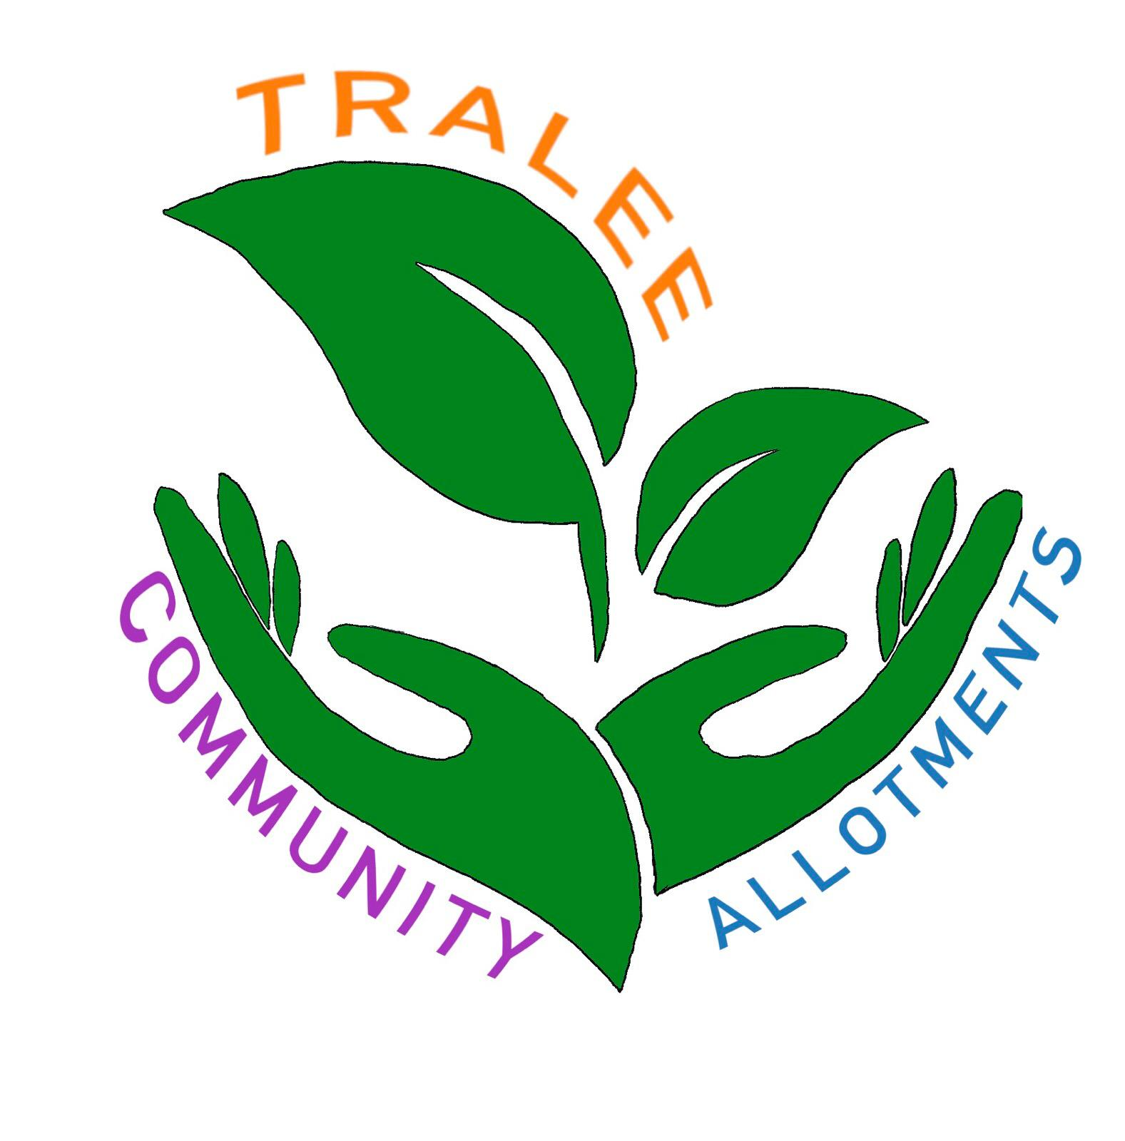
Tralee Allotment Application and Renewal Form
2024

PLEASE use Block Capitals/PRINT

Name:______________________________________________

Address:____________________________________________

Contact Number:____________________________________________

E mail Address:______________________________________

Allotment Location:__________________________________

Plot Number________________________________________

Start Date:_______________________ End date:____________________

I/ we understand that I/we are applying for/renewing the allotment plot and undertake the terms and conditions contained in the User Agreement. I/we also agree that my/our contact details can be used by the Tralee Allotment Steering Committee in order to keep me/us informed of activities and information.

Please tick fee paid and allotment type:

Fee categories | Regular  individual | Large  individual | Regular  Community | Large  Community
Yearly subscription | 30 | 60 | 60 | 100
Concession | 20 | 40 | 40 | 60
Supporter
(please add donation towards allotment expenses)

Signature(s):________________________________________

_________________________________________________

Date:_______________________________________

Email to: allotments@newkd.ie or transitionkerry2020@gmail.com

